At IL CENTRO is … Xmas time!

At IL CENTRO not only gift ideas for everyone, but also many events and services to live together unique emotions

Arese, Nov. 13th 2019 – Christmas is coming and at IL CENTRO, the mall of Arese, you can already breathe a festive atmosphere to celebrate together the most magical time of the year.

Let’s go shopping and…win!

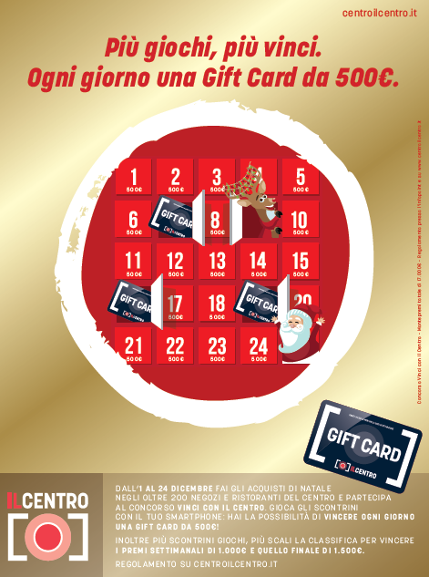
Christmas is time for gifts, to be done and... to be done to ourselves! From 1st to 24th December, all those who buy in any store and restaurant along the gallery, have the opportunity to participate in the competition "Win with IL CENTRO". To try your luck and win rich Gift Cards, just take a picture with your smartphone of the receipts, log on http://www.vinciconilcentro.it/ and simply discover if you win. More tickets played generates more opportunities to win the weekly prizes of € 1,000 and the final prize of € 1,500.

The prizes are:

- 1 Gift Card per day with a value of 500,00 €
- 1 Gift Card with a value of € 1.000,00 € from 1st to 7th December with draw within December 20th
- 1 Gift Card with a value of € 1.000,00 € from 8th to 14th December with draw within December 20th
- 1 Gift Card with a value of 1.500,00 € from 15th to 24th December with draw within January 10th.


The exclusive Christmas Gift Card, moreover, represents an original and useful gift idea to be given as a present to the person of the heart. All you have to do is choose the amount you want, and the gift is done! You can buy the IL CENTRO Christmas Gift Card from the website www.centroilcentro.flex-e-card.it, or by going to the infopoint (entrance 2) as well as to the automatic pads located near entrance 2 and on the first floor entering from entrance 4.

The events

Christmas is pure magic. For this reason, also this year IL CENTRO has planned a rich calendar of events dedicated to both adults and children:

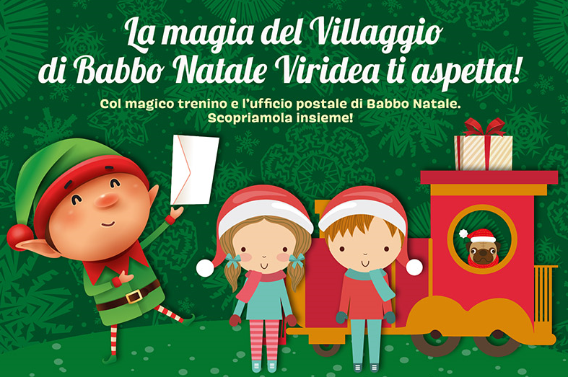
- Until Monday, December 23rd: the Magic of Christmas Viridea. Near the entrance 1, a real village of Santa Claus is waiting for everyone to meet and feel a fairytale atmosphere: children, but also adults, who want to deliver their letter of wishes to Santa Claus, will be able to deliver it directly to his trusted Elf by also taking a nice selfie with this character from the enchanted world. Santa's Elf will be present every weekend at 10.30 a.m. to 12.00 noon and from 3.30 p.m. to 8.00 p.m. until December 23rd. In addition, from 8th November to 6th January all on board the train on rail for an unforgettable ride inside the village decorated with festivities.

- From Friday 15th November to Monday 6th January: shopping opportunities also under the welcoming arcades of the mall. At entrance 4 (outdoor area Iper la grande i) the unavoidable Christmas markets will brighten up the area with many wooden houses decorated for festivities and where you can buy products of all kinds: from delicious jams to perfumers for environments, from wooden furniture accessories to handmade clothing accessories. All kinds of ideas to find the right inspiration for the perfect gift.

- From Friday 22nd November to Sunday 2nd February: IL CENTRO on-ice! On the occasion of the lighting of the evocative lights, at the events area of the Mall on the first floor, you can have fun on the ice with the long-awaited skating rink. 350sqm of natural ice available to all skaters, from the most experienced to beginners. For them, above all, it will be possible to request individual or group lessons with professional coaches FISG (Italian Federation of Ice Sports).
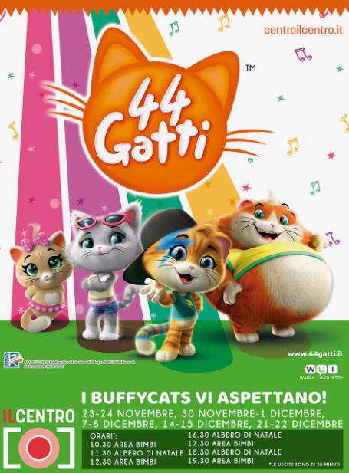
- From Saturday 23rd November to Sunday 22nd December: great news 2019! For this year, 44 cats will involve the young customers of the Mall during the weekends. The four cute cat musicians protagonists of the new Rainbow cartoon and who usually live in "Nonna Pina's house", will make their appearance in the gallery to take pictures with all the small fans at the children's area and under the Christmas tree on the ground floor, in the square in front of the store Primark.

- Sunday 15th and Sunday 22nd December: voices and songs in the gallery. The suggestive and award-winning all-female Aresine choir In Laetitia Chorus, accompanied by a trio of musicians who will warm up the atmosphere even more, will perform at IL CENTRO on two pre-Christmas Sundays from 11.00 to 12.00 to delight the audience with the interpretation of the most famous Christmas songs.

Services

- For Christmas, the shopping mall, as usual, will open until 11 pm from 13th to 23rd December to allow everyone to extend the shopping experience for the last gifts. On 24th and 31st December, the closing time will be brought forward to 19.30, while on 25th, 26th December and 1st January, IL CENTRO will remain closed.

- For all those who want to reach the Mall without using their own car, from November 30th to January 26th, this year IL CENTRO confirms the integrated shuttle service of 6 additional trips on the weekend, for a total of 12 trips a day. The ticket can only be purchased online on the website zaniviaggi.it at a cost of 5 euro return trip.

IL CENTRO … Christmas is already here!

About Tea: Tea Spa, part of Gruppo Finiper Spa, based in Milan, Via Ponchielli 7.

Press Office IL CENTRO

Say What? – Via Procaccini 73, Milano

Geraldina Soldadino g.soldadino.cons@saywhat.it Tel 02 3191181 – Cell. 388 393 8334
Silvia Destino s.destino@saywhat.it Tel 02 3191181

Timing: 10.00-20.00 on weekends and 15.00-19.00 on weekdays. Ticket price: 2 euros for one trip and 5 euros for 3 trips.
Timing: 14.00-21.00 Monday-Friday / 10.00-21.00 weekend / 10.00-21.00 from 23 December to 6 January. Ticket price: 5,00 euro (one hour including skate rental). Tutor price: 2,00 euro. Price for locker rental: 1,00 euro.

